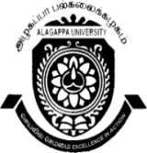
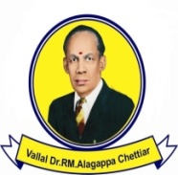
ALAGAPPA UNIVERSITY, KARAIKUDI –630003
(Reaccredited with “A” Grade by NAAC)
DIRECTORATE OF DISTANCE EDUCATION
(Recognized by Distance Education Bureau, (DEB), UGC, New Delhi)

Website:www.alagappauniversity.ac.in Email:dde@alagappauniversity.ac.in
Phone:04565-223420 Fax:04565-225216
Dr. T. R. GURUMOORTHY Date:23.03.2015 DIRECTOR

Sub: DDE - Conduct of P.C.P classes - reg.

*******

The Personal Contact Programme (PCP) of the following courses for the Academic Year 2014-2015 will be held as per the following schedule:-

Courses: B.Com, B.Com (CA), M.Com & M.Com (F&C)

Venue | Date | Time
Department of Mathematics,  Alagappa university,  Karaikudi. | 11 & 12.04.15,  18 & 19.04.15,  25 & 26.04.15 | 10.00 A.M  To  05.00 P.M

The Candidates are instructed to check their Name, Enrolment Number and Address given in the envelope with the Identity Card and discrepancies if any, should be reported to the undersigned immediately.

You are also advised to bring your I.D. Card at the time of attending PCP. It is very useful for the candidates to attend PCP all the days to sit for University examinations.

DIRECTOR
To
Student concerned

